Description on how to download EOD data from BigCharts:

Daily stock quotes for many countries can be downloaded from BigCharts. For example,
daily data on a specific date for symbol uk:chy is available on this URL:

http://bigcharts.marketwatch.com/historical/default.asp?detect=1&symb=uk:chy&closeDate=01/28/2009

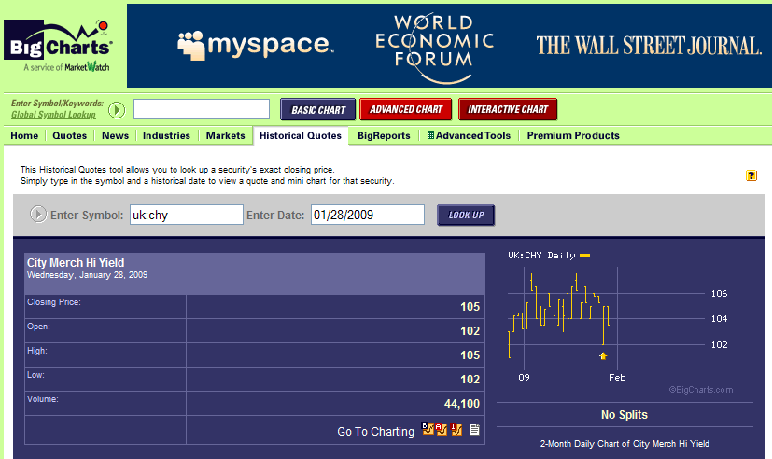

To get historical daily data for uk:chy, we will need HSQuote Plus to step through each date for the download period to get one day data at a time. The following set up will automate the process.

Set-up:

- Copy the following lines and append to your existing “mywebserver.txt”, or simply substitute it the attached “mywebserver.txt”.

BigCharts_DXXXX,http://bigcharts.marketwatch.com/historical/default.asp?detect=1&symb=SSSS&closeDate=MM1M/DDDD/YY4Y,D2,BigCharts_D2.fmt

- Copy the “BigCharts_D2.fmt” file to the “fmt” subfolder.
- Run HSQuote Plus and set up “BigCharts_D_UK.tic” as shown.

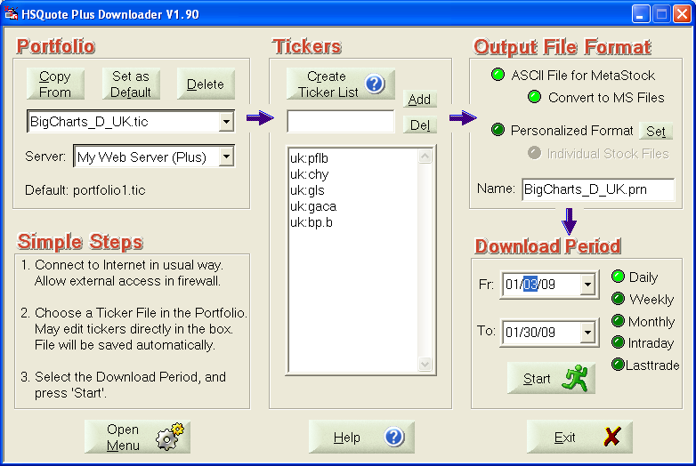

Historical Daily Data Download:

Specify the Download Period as usual. The download will step through one day at a time, as shown.
